Fibonacci

For other Resources
http://www.mcs.surrey.ac.uk/Personal/R.Knott/Fibonacci/fibnat.html

Plus

Leonardo, son of Bonaccio (‘good nature’) was an Italian mathematician who lived from about AD 1170 to AD 1250. Born in Pisa (the construction of the leaning tower was begun in his lifetime although not completed for nearly two centuries), he was brought up in Bougie on the north coast of Africa. His father was a merchant and Leonardo travelled to Egypt , Greece and Syria which brought him into contact with Eastern and Arabic mathematical practices.

The Fibonacci Sequence

In his book, Liber Abaci, Fibonacci posed a problem about breeding rabbits. The solution is this sequence of numbers

1, 1, 2, 3, 5, 8,

Can you see how the, sequence continues? You have to be given the first two numbers.
What is remarkable is that the sequence describes the pattern in various areas of life. (See Frank Land’s book, The Language of Mathematics)
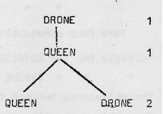
The Family Tree of Queen and Drone Bee
A male bee, called a drone has only one parent, the queen. A queen, however has both a mother (queen) and a father (drone)

The family tree below traces a drone’s ancestors back as far as his grandparents; the number of bees is listed. On a clean sheet, copy the tree and continue it back for at least four more generations (assume no inter— marriage). List the number of bees in each generation

You may have found that the number of bees in each generation gave you the Fibonacci Sequence.

Write down the number of drones in each generation from your tree diagram. As well as describing patterns in Nature, the Fibonacci Sequence has many interesting properties. -
‘In 1963 a group of people became interested in- this sequence of numbers and formed a society called the Fibaonacci Association. Within two years the Association published some 600 pages of the results of their investigations into the sequence’ —Making Mathematics book 4 p46.

Here are the first seven terms of the Fibonacci Sequence with another sequence beneath it..
1, 1, 2, 3, 5, 8, 13,
0 1 1 2 3

Find out how it was obtained from the Fibonacci Sequence.
Copy and continue.
Make a third sequence below the second one, by writing down the differences between the terms of the second one.

This list shows the values of the first eight terms of the Fibonacci Sequence:
term: 1 2 3 4 5 6 7 8
value: 1, 1, 2~ 3, 5, 8, 13, 21

Copy the list, and continue it up to at least the fifteenth term.

When complete, the following table will exhibit some properties of the Fibonacci Sequence
Make the table for yourself, and complete it.

Which terms have values that are:—
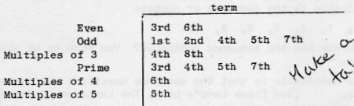

Write some notes to- record properties of the Fibonacci Sequence that you notice.

Invent a pattern to illustrate the Fibonacci Sequence.

Take four consecutive terms, eg. 2, 3, 5, 8
Multiply the two OUTSIDE numbers (2x8 = 16)
“ “ INSIDE (3x5 = 15)

The difference between these results is I

Does this work with other sets of four consecutive Fibonacci numbers?

Not so much something to be slogged through — more a collection of starting points to suggest how work on this topic might continue.

A certain kind of tree produces a new shoot every season, except that it does not produce during its first year of growth.
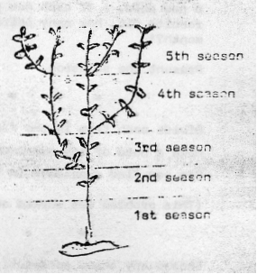
Tha diagram shows the development after five years.

Copy and complete the table up to at least the eighth season:—

Season 1 2 3 4
No. of shoots 1 1 2 3

Select any three consecutive Fibonacci numbers
eg. 2, 3, 5
Multiply together the two outside numbers
2 x 5 = 10
Square the middle number 3² = 9
What do you notice?
Try this for different sets of three consecutive numbers.

Square and add two consecutive Fibonacci numbers.
What do you notice about the result?
Try it for several more pairs.

Can. you generalise your results? That is can you find a way or predicting what the result would be of adding the squares of:
- the third and. fourth terms, . -.
- the fifth and sixth, . . - -
- the 100th and 101st,
- etc…

Square each of the first five Fibonacci numbers and add the results.
1² + 1² + 2² + 3² + 5² = 1 + 1 + 4 + 9 + 25 = 40

Multiply the last number in the list and the next one 5 x 8 = 40

What do you notice?

Does this work for other sets of consecutive Fibonacci numbers?

Choose two numbers of your own and make up your own ‘Fibonacci’ sequence. Compare and contrast its behaviour with the Fibonacci Sequence.

This is the rabbits problem from LIBER ABACI;

‘A pair of rabbits one month old are too young to produce more rabbits, but suppose that in their second month and every month thereafter they produce a new pair. If each new pair of rabbits does the some~ and none of the rabbits die, how many pairs of rabbits will there be at the, beginning of each month?

Present the solution.

Divide each term in the Fibonacci Sequence by 4
Make a note of any remainder.
Can you find a pattern in the remainders?
(This problem was worked on by Lagrange)

Choose any three consecutive Fibonacci numbers.

Add the cube of the second to the cube of the third and subtract the cube of the first.
What do you notice about the result?
Can you generalise this?

Find the sum of the first four terms of the sequence.
Notice that the sum is one less than the sixth term.

Find the sum of the first five terms of the sequence.
Is the sum one less than the seventh term.

Generalise your results.

The number of petals of many flowers are Fibonacci numbers.
‘‘Not every flower is identical but, for instance a couple of typical values are:
Lilies and irises 3 petals
Butteroups 5 petals

More information Frank Land’s book, and ‘I can count the petals of a flower’ by John & Stacey Wahl.

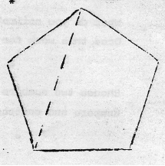
Draw a regular pentagon of side 3 cm.

Measure and record in cm the length of a diagonal.

Repeat for a regular pentagon of side
(a) 5 cm (b) 8 cm

What do you notice?

Whet do you think is the approximate length of a regular pentagon’s diagonal if the side is
(a) 13 cm (b) 21 cm?

